
May Day Race
May 5, 2018
Hosted by 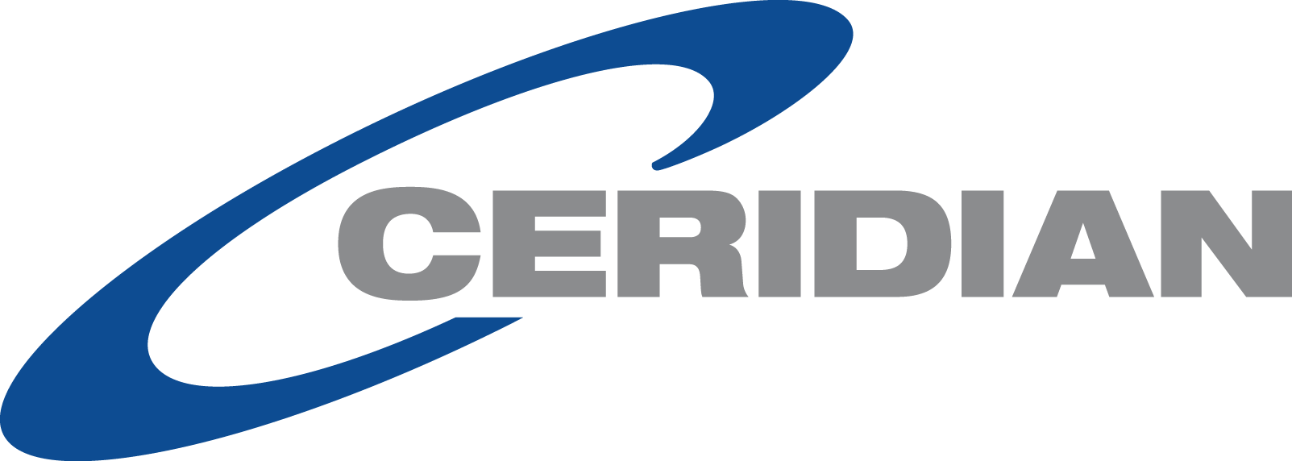

Proceeds will benefit the Skyway Marina District Assn (501c3 Corp.)
and local school programs

2018 Sponsorship Opportunities:

MAJOR SPONSOR (1) - $5,000

- Logo featured on event towels
- Opportunity to present post-race awards
- Logo featured prominently on all marketing materials (the full color event flyers, news media advertisements and event banner)
- Logo featured on event Facebook, Social Media and E-blasts, and Website
- Promotional materials included in participants goodie bags
- Opportunity to display banners on site
- Complimentary vendor space at the pre and post race party
- Ten complimentary race entries

TIMING & BIB SPONSOR (1) $2,000

- Logo featured on all participant race bibs
- Opportunity to put coupon or other advertisement on race bibs
- Logo on full color event flyers and towels
- Opportunity to display banners on site
- Complimentary vendor space at the pre and post race party
- Promotional materials included in participant goodie bags
- Five complimentary race entries

SPONSOR A SCHOOL - $750 (5)
(This sponsorship will provide funding for up to 30 kids/teachers at a local school of your choice to participate in the race)

- Logo on a Peach Jar Ad (Sent to all parents at the school of your choice)
- Logo on full color event flyers and towels
- Complimentary vendor space at the pre and post race party
- Opportunity to include promotional materials in participant goodie bags

WATER STOP SPONSOR - $500 (2)

- Banner with your logo at the featured water stop (volunteer staffing optional)
- Logo on full color event flyers and towels
- Complimentary vendor space at the pre and post race party
- Opportunity to include promotional materials in participant goodie bags

COURSE SPONSOR - $500 (Unlimited)

- Logo on at least 2 course signs
- Logo on full color event flyers and towels
- Complimentary vendor space at the pre and post race party
- Opportunity to include promotional materials in participant goodie bags

MAY DAY SPONSOR - $375 (Unlimited)

- Logo on full color event flyers and towels
- Complimentary vendor space at the pre and post race party
- Opportunity to include promotional materials in participant goodie bags

VENDORS - $75 (20)

- Vendor space at the pre and post race party

IN KIND SPONSOR

- Sponsors are needed for the following in-kind donations
  - Breakfast
  - Water
  - Snacks
  - Race Prizes (adult and kids)
  - Encouragement signs on the course
  - Printing Services
  - Advertising and Marketing Services

