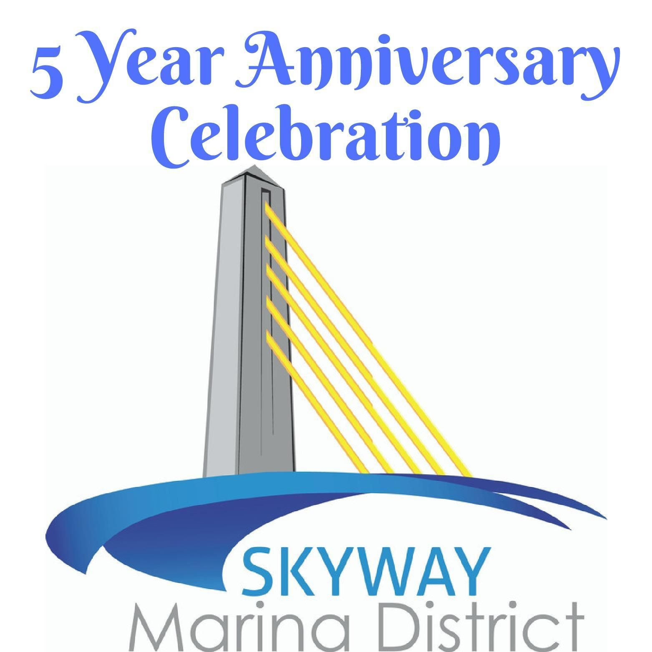

2018 Vendor Application Saturday, October 6th, 2018. 1pm to 7pm
Set-up from 12pm till 1pm Take down from 7pm - 8pm Check one, Please:
_____Food Vendor _____Business Vendor

--Food Vendors are original, hand-made food
--Business Vendors are everything else! (Corporate Sponsors often receive a booth-space with their sponsorship package; please mark “Business Vendor”. Thanks!)

Owner Name ____________________________ Business Name___________________________

Address______________________________________________________________________________

Phone _______________________________________________________________________________

Email ________________________________________________________________________________

Website __________________________________Facebook ________________________________

Food Vendor Fee: $100 for approx.. 20x10 space Business Vendor: $50 for
non-members (contact us to become a member), $25 for members - for approx.. 10x10 space

- Your booth needs to be accepted by the Festival Director (Food Vendors, please send a menu of what you intend to sell at the celebration)
- Electricity is not provided.
- Fees need to be paid in advance of celebration (by 9-15-2018). (Your booth-space will not be reserved until you’ve paid your fee)
- Booths and Food Trucks must remain open the entire celebration.
- Please attach proof of insurance w/ Skyway Marina District (4801 37th Street S. , 33711) and City of St. Petersburg (P.O. Box 2842, 33731) as Additional Insured.
- Food Truck exclusivity will apply - first come, first serve.
- Tables & Chairs will not be provided.
- 10x10 Tents ONLY!

Skyway Marina District is a Non-Profit Organization
4801 37th Street S. St. Petersburg FL 33711
Director@skywaymarina.com
727-466-7173

